
  - CENTRAL REPTILE REHOME NETWORK

reptile RESCUE & SURRENDER POLICY
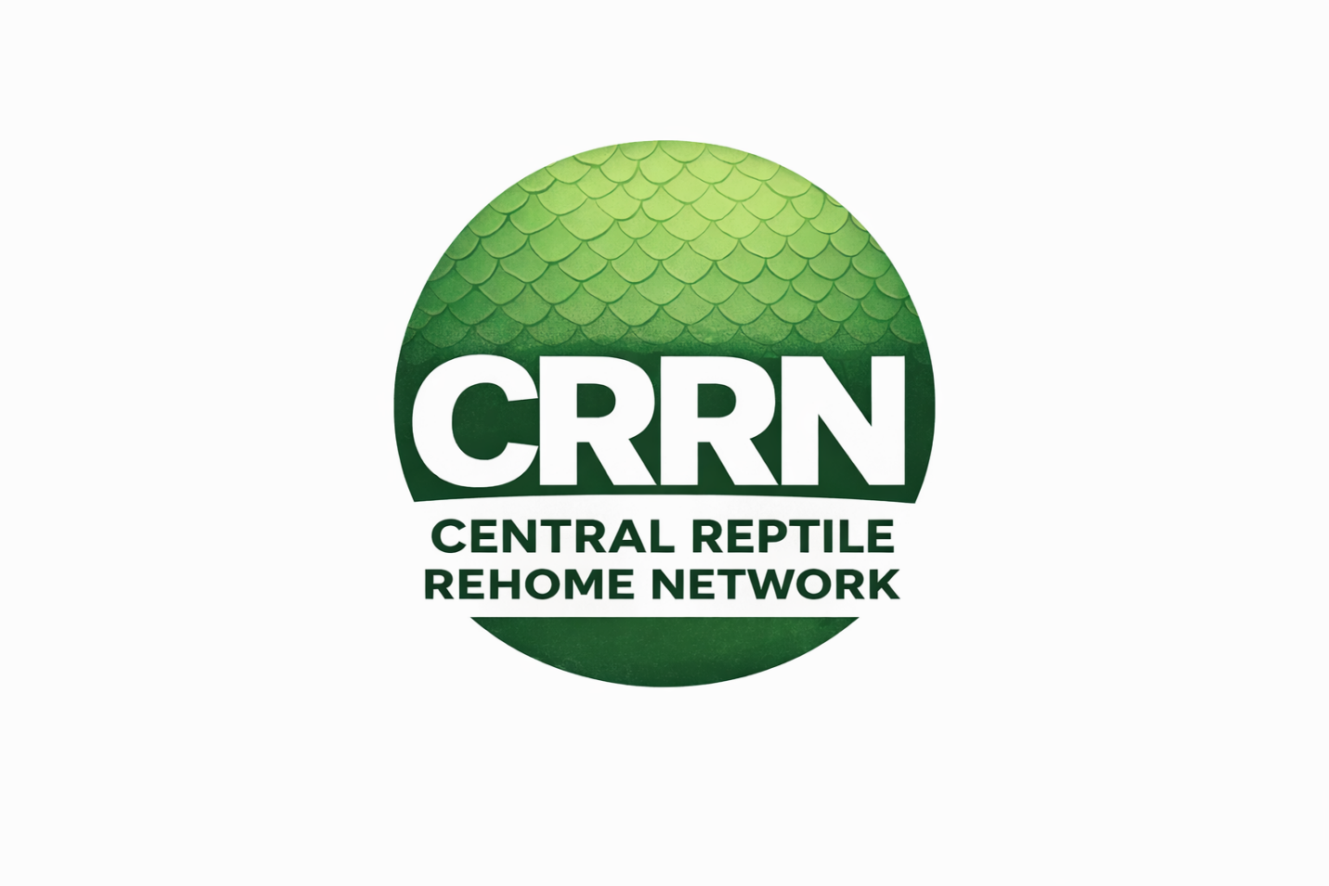

Document version 2


rEPTILE RESCUE & SURRENDER POLICY IS BASED ON CURRENT VERSION OF THE ANIMAL WELFARE ACT (AWA 2006)
This policy may be updated in accordance with current/future amendments to the Animal Welfare Act 2006. CRRN will notify and publish accordingly.

Central Reptile Rehome Network (CRRN)
Reptile Rescue & Surrender Policy

1. Purpose
This policy outlines the procedures and expectations for the intake, rescue, and surrender of reptiles within the Central Reptile Rehome Network (CRRN).
It is designed to:
- Safeguard the welfare of reptiles entering rescue
- Protect rescues from legal and ethical risk
- Ensure consistent, transparent surrender processes
- Support responsible rehoming outcomes

2. Legal Framework
All rescues must operate in line with the Animal Welfare Act 2006.
Key principles:
- Reptiles are legally considered property
- Ownership cannot transfer without:
  - Signed surrender
  - Legal authority (e.g. police/court)
Rescues must not remove or retain animals without lawful authority or owner consent.

3. Types of Intake
CRRN recognises three primary intake routes:
3.1 Voluntary Surrender
- Owner willingly gives up the animal
- Must be supported by a signed surrender form
- Ownership transfers to the rescue

3.2 Emergency Intake (With Authority)
- Animal removed due to welfare concerns
- Involvement of:
  - Police
  - Welfare organisations
  - Local authority
Requirements:
- Incident or reference number (if applicable)
- Written confirmation of transfer
- Clear understanding of ownership status

3.3 Assisted Rehoming (Owner Retained)
- Rescue supports rehoming process
- Animal may remain with current owner
- Rescue does not assume ownership unless surrendered

4. Surrender Requirements
Before accepting an animal, rescues must:
- Obtain a completed surrender form, including:
  - Owner details
  - Animal details
  - Reason for surrender
- Confirm the owner has the legal right to surrender the animal
- Clearly explain:
  - Ownership transfer (if applicable)
  - That the animal may be rehomed
Rescues must refuse intake where:
- Ownership is unclear
- Consent cannot be verified
- Welfare would be compromised due to lack of capacity

5. Emergency & Welfare Concerns
Where welfare concerns are present:
Rescues must:
- Advise contacting appropriate authorities where required
- Avoid independently “seizing” animals
- Only act where:
  - Consent is given
  - Or authority is present
CRRN rescues do not have enforcement powers.

6. Intake Assessment
Upon intake, rescues must:
- Carry out an initial welfare assessment:
  - Body condition
  - Visible injury or illness
  - Behaviour and stress levels
- Record:
  - Feeding history (if known)
  - Current housing conditions
- Photograph condition on arrival (recommended)

7. Quarantine & Biosecurity
All new arrivals should:
- Be treated as potential biosecurity risks
- Be housed in quarantine where possible
- Be monitored before introduction to other animals

8. Capacity & Responsibility
Rescues must:
- Operate within their capacity limits
- Avoid over-accepting animals due to pressure or urgency
- Prioritise welfare over intake numbers
Saying “no” or “not at this time” is acceptable and responsible.

9. Transparency & Communication
Rescues must:
- Be honest about:
  - Animal condition
  - Known health issues
  - Behavioural concerns
- Avoid misleading or incomplete information
- Communicate clearly with surrendering owners and adopters

10. Rehoming Responsibility
Before rehoming, rescues must:
- Ensure the animal is fit for rehoming
- Provide accurate information to adopters
- Carry out appropriate adopter checks
- Avoid rushed or convenience-based rehoming

11. Fees & Financial Transparency
Rescues may:
- Charge reasonable surrender or adoption fees
However:
- Fees must not be exploitative
- Rescue must not operate for profit
- Financial practices must be transparent where questioned

12. Prohibited Practices
CRRN rescues must not:
- Take animals without consent or authority
- Misrepresent animals for rehoming
- Accept animals purely for resale or profit
- Bypass welfare checks to speed up rehoming
- Encourage irresponsible surrender practices

13. Owner Expectations
Surrendering owners should:
- Provide accurate and honest information
- Disclose known health or behavioural issues
- Understand that:
  - The rescue may rehabilitate and rehome the animal
  - Ownership may transfer permanently

14. Record Keeping
Rescues must maintain:
- Surrender documentation
- Intake records
- Rehoming outcomes
These support:
- Accountability
- Welfare tracking
- Transparency

15. Compliance & Accountability
CRRN operates on:
- Self-regulation
- Welfare-led standards
- Transparency and trust
Rescues are expected to:
- Follow this policy in good faith
- Accept feedback and guidance
- Continuously improve practices
Failure to meet expectations may result in removal from the network.

16. Statement of Commitment
All CRRN rescues agree to:
Handle all rescue and surrender cases responsibly, lawfully, and in the best interests of the animal, ensuring welfare, transparency, and accountability at all times.

