
  - CENTRAL REPTILE REHOME NETWORK

reptile WELFARE POLICY
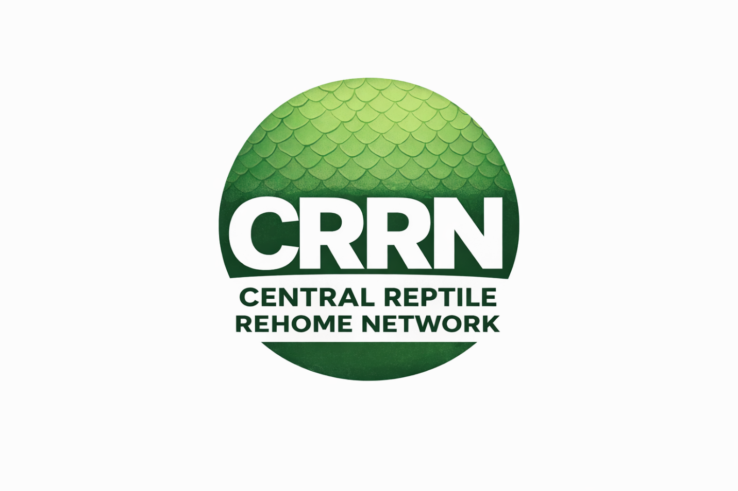

Document version 2


rEPTILE WELFARE POLICY IS BASED ON CURRENT VERSION OF THE ANIMAL WELFARE ACT (AWA 2006)
This policy may be updated in accordance with current/future amendments to the Animal Welfare Act 2006. CRRN will notify and publish accordingly.

Central Reptile Rehome Network (CRRN)
Animal Care & Welfare Policy

1. Purpose
This policy sets out the minimum animal care and welfare expectations for all rescues operating within the Central Reptile Rehome Network (CRRN).
It is designed to:
- Promote consistent, welfare-led care standards
- Safeguard reptiles within rescue environments
- Support responsible rehabilitation and rehoming
- Align all member rescues with UK legal welfare requirements

2. Legal Framework
All CRRN rescues must operate in accordance with the Animal Welfare Act 2006, which places a legal duty of care on anyone responsible for an animal.
Under Section 9 of the Act, animals must have their welfare needs met, including:
- A suitable environment
- A suitable diet
- The ability to exhibit normal behaviour
- Appropriate housing (with or without other animals)
- Protection from pain, suffering, injury and disease
Failure to meet these needs may constitute an offence.

3. Core Welfare Principles
All CRRN rescues must operate under the following principles:
- Welfare First: Animal wellbeing must take priority over capacity, demand, or convenience
- Transparency: Husbandry, intake, and rehoming practices must be open and honest
- Accountability: Rescues must be able to justify their standards and decisions
- Responsibility: Animals must only be taken in when appropriate care can be provided

4. Intake & Capacity Management
Rescues must:
- Only accept animals within their capacity to care safely and appropriately
- Avoid overcrowding or compromised welfare due to intake pressure
- Assess each animal on intake, including:
  - Visible health condition
  - Behaviour and stress levels
  - Immediate husbandry requirements
Rescues must be prepared to say “no” or “not at this time” where capacity or welfare would be compromised.

5. Housing & Environment
All reptiles must be provided with:
- Enclosures appropriate to their species, size, and behaviour
- A clear thermal gradient (where required)
- Suitable substrate appropriate to species needs
- Access to secure hides
- Adequate space to move and exhibit natural behaviours
- Species-appropriate humidity and ventilation
Temporary or quarantine setups are acceptable where necessary, provided welfare is not compromised.

6. Nutrition & Hydration
Rescues must ensure:
- Diets are appropriate for the species and life stage
- Feeding is consistent and monitored
- Clean, accessible water is always available (where required)
- Nutritional deficiencies are identified and addressed

7. Health & Veterinary Care
All CRRN rescues must:
- Be registered with a qualified veterinary practice
- Seek veterinary attention when animals show signs of:
  - Illness
  - Injury
  - Parasites or infection
- Maintain basic health records for animals in their care
Delaying or avoiding necessary veterinary treatment is not acceptable.

8. Hygiene & Biosecurity
Rescues must:
- Maintain clean enclosures and equipment
- Implement basic quarantine procedures for new arrivals
- Prevent cross-contamination between animals
- Use safe and appropriate cleaning products

9. Behaviour & Handling
Rescues must:
- Minimise stress during handling
- Avoid unnecessary handling, especially during acclimatisation
- Recognise species-specific behaviour and stress indicators
- Ensure handling is appropriate and safe

10. Rehabilitation & Rehoming Readiness
Before rehoming, rescues must ensure:
- The animal is stable and fit for rehoming
- Feeding behaviour is established where possible
- Health concerns are disclosed transparently
- The animal has been assessed for suitability for rehoming
Animals should not be rehomed prematurely to reduce workload or create space.

11. Rehoming Responsibility
Rescues must:
- Vet potential adopters appropriately
- Ensure adopters understand the long-term commitment
- Provide basic care guidance where needed
- Act in the best interest of the animal at all times

12. Record Keeping
Rescues should maintain:
- Intake records
- Basic health observations
- Rehoming records
Accurate records support transparency and accountability.

13. Prohibited Practices
CRRN rescues must not:
- Operate for profit under the guise of rescue
- Take in animals without the ability to meet welfare needs
- Rehome animals irresponsibly or without assessment
- Provide knowingly inadequate housing or care
- Misrepresent animals or their condition

14. Compliance & Accountability
CRRN operates on:
- Self-assessment
- Honesty and transparency
- Welfare-led accountability
Rescues are expected to:
- Reflect on their practices
- Accept constructive feedback
- Continuously improve standards
Failure to meet core welfare expectations may result in removal from the network.

15. Statement of Commitment
All CRRN rescues agree to:
Provide care that meets or exceeds the welfare needs set out in the Animal Welfare Act 2006, act responsibly and transparently, and place the wellbeing of reptiles above all other considerations

