
  - CENTRAL REPTILE REHOME NETWORK

reptile REhome POLICY
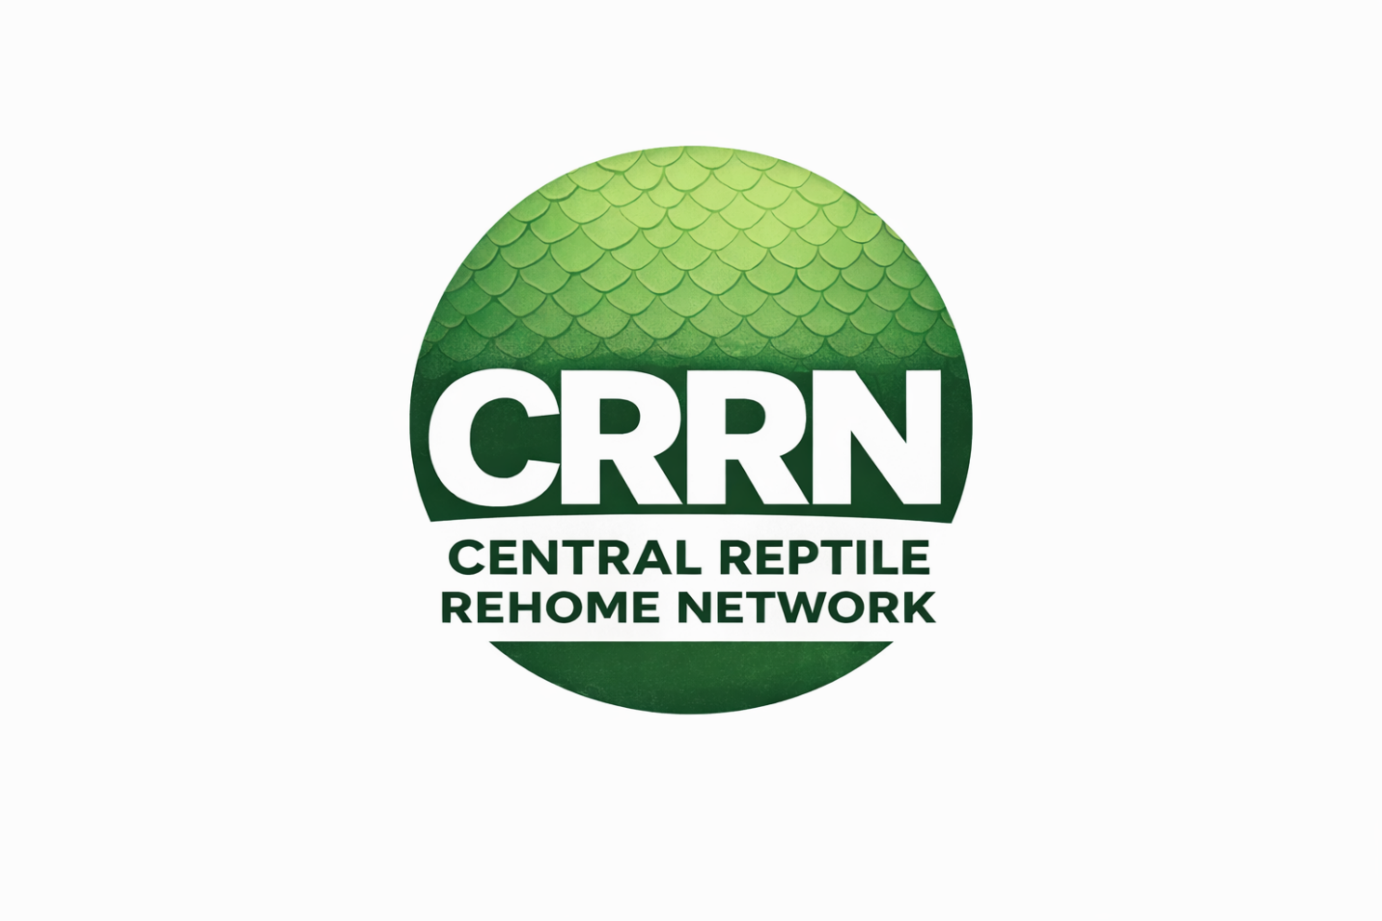

Document version 2


rEPTILE REhome POLICY IS BASED ON CURRENT VERSION OF THE ANIMAL WELFARE ACT (AWA 2006)
This policy may be updated in accordance with current/future amendments to the Animal Welfare Act 2006. CRRN will notify and publish accordingly.

Central Reptile Rehome Network (CRRN)
Rehoming Policy

1. Purpose
This policy outlines the standards and procedures for the rehoming of reptiles within the Central Reptile Rehome Network (CRRN).
It is designed to:
- Ensure safe, responsible, and welfare-led rehoming
- Protect reptiles from unsuitable or exploitative placements
- Support adopters in providing appropriate long-term care
- Promote transparency and accountability across all rescues

2. Legal Framework
All rehoming activities must align with the Animal Welfare Act 2006, ensuring that the welfare needs of reptiles are met both during and after rehoming.
Rescues must:
- Act in the best interest of the animal
- Ensure adopters understand their legal duty of care

3. Rehoming Principles
All CRRN rescues must operate under the following principles:
- Welfare First: Rehoming decisions must prioritise the animal’s long-term wellbeing
- No Rushed Placements: Animals must not be rehomed for convenience or space
- Right Home, Not First Home: Suitability outweighs speed
- Transparency: Full disclosure of the animal’s condition and needs
- Accountability: Rescues must stand by their rehoming decisions

4. Rehoming Criteria
An animal must only be rehomed when:
- It is medically stable (or condition fully disclosed)
- Feeding behaviour is established (where possible)
- It has completed any required quarantine or observation period
- Its care requirements are clearly understood
Animals must not be rehomed if:
- They are critically unwell (unless agreed under specialist circumstances)
- Their needs cannot be realistically met by an adopter

5. Adopter Assessment
All potential adopters must be assessed prior to rehoming.
This should include:
- Completion of an adoption application form
- Review of:
  - Experience with reptiles
  - Knowledge of species-specific care
  - Proposed enclosure and setup
- Request for photo evidence of setup (where possible)
- Confirmation of:
  - Heating and lighting provision
  - Appropriate enclosure size
  - Suitable substrate
Rescues must decline applications where welfare concerns exist.

6. Setup & Husbandry Requirements
Adopters must demonstrate:
- A species-appropriate enclosure
- Correct heating, lighting, and environmental controls
- Suitable substrate and enrichment
- Understanding of feeding and ongoing care
Rescues must not rehome animals into:
- Inadequate or unprepared setups
- Temporary arrangements without clear long-term plans

7. Transparency & Disclosure
Rescues must provide adopters with:
- Accurate details of:
  - Health status
  - Feeding behaviour
  - Known history (where available)
- Any ongoing care requirements
- Honest expectations regarding:
  - Lifespan
  - Costs
  - Commitment
Misrepresentation is strictly prohibited.

8. Rehoming Agreement
All adoptions must be supported by:
- A signed rehoming agreement, confirming:
  - Transfer of ownership
  - Adopter responsibility
  - Understanding of care requirements
The agreement should include:
- Animal details
- Condition at time of rehoming
- Date of transfer

9. Adoption Fees
Rescues may charge an adoption fee to support:
- Veterinary care
- Feeding and maintenance
- Operational sustainability
However:
- Fees must be reasonable and transparent
- Animals must not be priced for profit

10. Post-Rehoming Responsibility
Rescues should:
- Offer guidance and support where needed
- Encourage responsible ownership
- Maintain a professional and supportive relationship
Optional:
- Follow-up checks or updates

11. Returns Policy
Rescues should:
- Encourage adopters to return animals if they can no longer care for them
- Provide a clear return process
Animals must not be:
- Passed on without assessment
- Sold or traded irresponsibly

12. Prohibited Practices
CRRN rescues must not:
- Rehome animals without adopter checks
- Allow “first come, first served” placements
- Rehome animals through unverified third parties
- Encourage impulse adoption
- Allow animals to enter cycles of repeated rehoming

13. Public Responsibility
Rescues and adopters share a responsibility to:
- Promote responsible reptile ownership
- Challenge poor welfare practices
- Support transparency within the community

14. Compliance & Accountability
CRRN operates on:
- Self-regulation
- Transparency
- Welfare-led accountability
Rescues are expected to:
- Follow this policy
- Justify rehoming decisions if questioned
- Continuously improve standards
Failure to meet expectations may result in removal from the network.

15. Statement of Commitment
All CRRN rescues agree to:
Rehome reptiles responsibly, ensuring every placement is safe, suitable, and in the best long-term interest of the animal, with welfare placed above all other considerations.

